AP Calc AB Name: _______________

______________ _____________

WS Assessment

Target 13:

First and second derivative test

**I can:**

* Justify conclusion about the behavior of a function base on the behavior of its derivatives

Unit 5: Analytical Applications of Differentiation

HW Target 13

Unit 5 Progress Check MCQ B and C

For the graph of the functions below, tell if it has limit, continuous, and differentiable at x → c

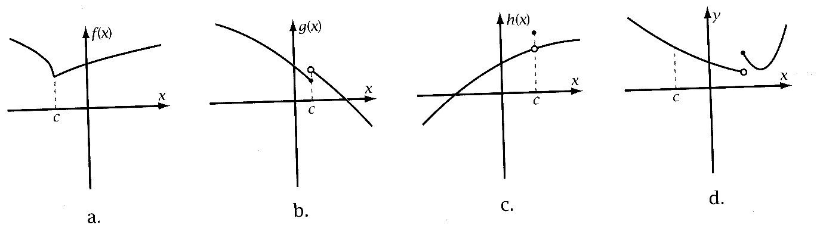

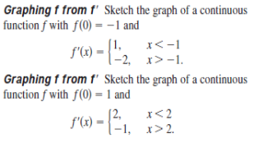

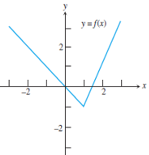

Sketch the graph of a function f that

has the following properties:

a. f(0) = 0

b. the graph of f ' is shown

c. f is continuous for all x.

**First derivative test**

|  |  |  |  |
| --- | --- | --- | --- |
| First derivative f $'$ (x) | Positive ( +) | c | Negative ( – ) |
| Function f(x) | Increase | Max | Decrease |

|  |  |  |  |
| --- | --- | --- | --- |
| First derivative f $'$ (x) | Negative ( – ) | c | Positive ( +) |
| Function f(x) | Decrease | Min | Increase |

**Second derivative test**

|  |  |  |  |
| --- | --- | --- | --- |
| With f ' (c) = 0 and | f ' ' (c) < 0 | f ' ' (c ) > 0 | f ' ' (c) = 0 |
| Function | Maximum, Concave down | Minimum, Concave Up | Neither max or min  Inflection point |

For each of the functions and intervals given below, find:

* the critical points of the function,
* where the function is increasing and where it is decreasing,
* where the function is concave up and where it is concave down,
* the inflection points,
* the local minimums and local maximums, and
* the absolute minimum and absolute maximum, if any.

f(x) = x3 - 12x + 5, [-5, 3]  f(x) = x2 - 5x + 6, (-1, 3]

f(x) = x tan(x), [-https://oregonstate.edu/instruct/mth251/cq/Symbols/pi.lc.gif, https://oregonstate.edu/instruct/mth251/cq/Symbols/pi.lc.gif]  f(x) = x/2 + sin(x), [0, 3]

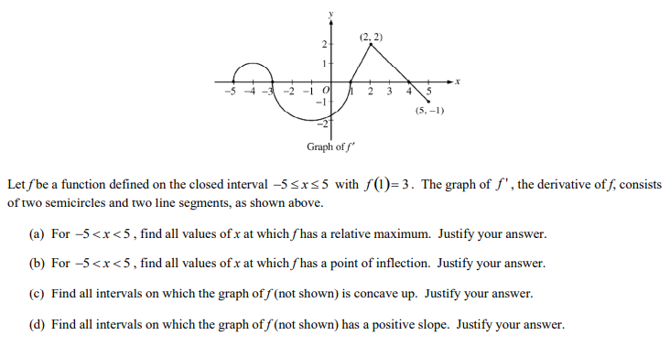

Find the inflection points and use the second derivative test, if possible, to classify the critical points. Also, determine the intervals of increase/decrease and the intervals of concave up/concave down and sketch the graph of the function

$f\left(x\right)=3x^{5}-5x^{3}+3$ $f\left(x\right)=x{(6-x)}^{\frac{2}{3}}$

**Curve Sketching**

Algebra and pre-calculus Limits 1st Derivative 2nd Derivative

1. Domain and Range 5. Vertical Asymptotes 7. Increase/Decrease 9. Concavity

2. y-Intercept 6. Horizontal and/or 8. Relative Extrema 10. Inflection

3. x-Intercept(s) Oblique Asymptote(s) Points

4. Symmetry

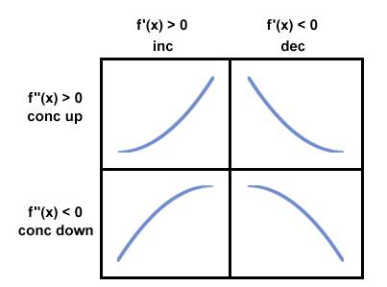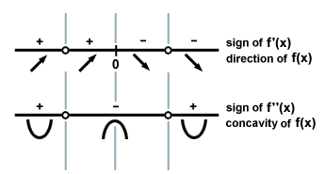

Do detailed graphing for $f\left(x\right)=\frac{1}{x^{2}-9}$

 Do detailed graphing for *f*(*x*) = *x*3 - 3*x*2

$ f(x) = \sin x - \sqrt{ 3 } \cos x $ Do detailed graphing for *x* in [0, 2pi]

Consider the cubic polynomial y = Ax3 + 6x2 - Bx , where A and B are unknown constants. If possible, determine the values of A and B so that the graph of y has a maximum value at x= -1 and an inflection point at x = 1

Assessment

Determine the interval(s) where f(x) is increasing.

where f(x) is decreasing.

f(x) is concave up.

f(x) is concave down.

Determine the value(s) of x where f(x) has relative (local) extrema. Classify each as the location of a relative maximum or a relative minimum.

Determine the value(s) of x where f(x) has an inflection point.

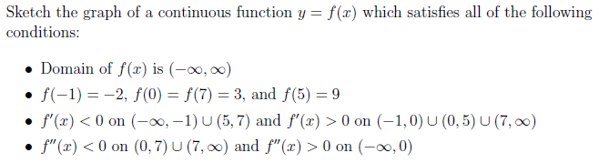

 Do detailed graphing of $f\left(x\right)=\frac{4x}{x^{2}-1}$